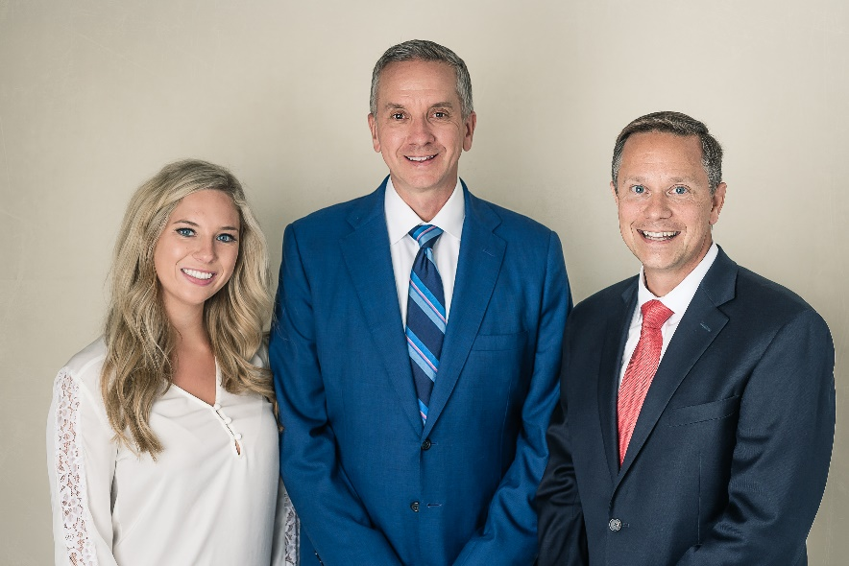
Pictured left to right: Jacqueline R. Sheehan, Christopher G. DeRuyver, Grier C. Edwards

Chelsea State Bank Announces Partnership with Affinity Wealth Solutions to Offer Financial Services (9/18/19)

In March of this year, Chelsea State Bank (CSB) partnered with Affinity Wealth Solutions to offer financial services to their customers. Affinity Wealth Solutions gives CSB customers accessibility to investment solutions that are outside of CSB’s current bank offerings. Investment solutions that Affinity Wealth offers to CSB customers include; investment management, retirement planning, estate planning, insurance planning, education funding, and charitable giving strategies. “We are excited to partner with Affinity Wealth Solutions," said John Mann, CSB Chairman and CEO. "We have already had great feedback from our customers about their experience in working with the Affinity Wealth Solutions team.”
Affinity Wealth Solutions, an established Ann Arbor based financial services firm has been assisting clients with their investment needs for over 26 years led by its president and founder, Christopher G. DeRuyver. The Affinity Wealth team consist of Christopher G. DeRuyver, Grier C. Edwards, and Jacqueline R. Sheehan. As a team, they partner with clients to educate and explain investment options available to meet client’s needs. When it comes to investing there is no one size fits all. Affinity Wealth understands that each client’s goals, ambitions, and dreams for their future make them unique. “We become our clients partner working together to assist them in meeting their financial goals,” said Christopher G. DeRuyver. “We are in the business of changing lives.” Affinity Wealth brings clarity and accountability to client’s investment life while easing clients stress and anxiety about investing.

About the recent partnership, Chris said, “We look forward to meeting and assisting CSB customers with their investments. We have already received a warm welcome and are enjoying getting to know everyone.” Affinity Wealth Solutions meets with clients at any of the three CSB locations or at their Ann Arbor location in Kerrytown.

www.affinitywealthsolutions.com
734.769.1427
Christopher DeRuyver of Affinity Wealth Solutions offers securities and advisory services through Commonwealth Financial Network®, member FINRA/SIPC, a Registered Investment Adviser. Investments are not insured by the FDIC and are not deposits or other obligations of, or guaranteed by, any bank or depository institution. Funds are subject to investment risks, including possible loss of principal investment. Chelsea State Bank is not a registered broker-dealer or Registered Investment Adviser. Chelsea State Bank and Commonwealth are separate and unaffiliated entities. Fixed insurance products and services offered through Affinity Wealth Solutions. Investments are not insured by any federal government agency.

